Image | 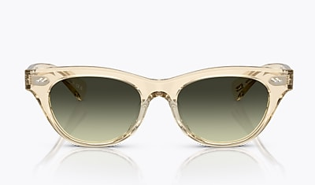
Brand | OLIVER PEOPLES
Model Name | Avelin
Price | RS 4850
PRODUCT DETAILS

